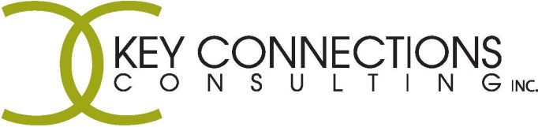

Part-Time Youth Program Facilitator
Come join our growing team!!

Key Connections Consulting Inc. (KCC) is a family centered, multidisciplinary team of professionals including Behaviour Consultants, Counsellors, Speech-Language Pathologists, and Occupational Therapists. We are dedicated to improving the lives of children, youth, and adults with challenges by supporting them to reach their full potential.

We are currently recruiting a Part-Time Program I.C.E. (Independence. Competency. Employment.) Facilitator. The position is located in Lethbridge, AB and is available immediately. KCC provides a unique and positive work environment, competitive wages, and benefits. KCC provides frequent case consultation / clinical supervision / shadowing / mentorship and professional development opportunities encouraged and supported through a professional spending account. KCC offers a very flexible work schedule; valuing a family first philosophy.

- We are looking for a diverse, enthusiastic and innovative professional with the ability to multi-task and manage a flexible schedule.
- The successful candidate will co-facilitate group programming to youth with developmental or mental health needs. Programming will include the developmental of life skills and pre-employment training.
- An understanding of varied socio-economic factors, and competency supporting multi-cultural needs is beneficial.
- Familiar with developmental disabilities and mental health is a requirement.
- Strong coaching skills, positive communication skills, and the ability to motivate others.
- Late afternoon and evening shifts will be required.

Additional requirements include:
- BSW, Child and Youth Care or related Degree, who have significant related experience
- Ideally a Licensed or Registered Health Care Provider under the Health Professions Act
- Valid Driver’s License and access to a vehicle
- Criminal Record and an Intervention Record Check are required
- Experience working with at risk youth and/or developmental disabilities is an asset
- Current First Aid Certificate is an asset

Resumes will be accepted until a suitable candidate is found. Must include a Cover Letter.
Please email or fax resumes to:
Contact@KeyConnectionsConsulting.com or 403-317-1628 (fax).
www.KeyConnectionsConsulting.com

